BIOS 6643 – Generalized Linear Models (GzLM) – Grunwald – Fall 2013

Homework questions
Where appropriate include brief and annotated SAS or R output

By far the three most common cases for generalized linear models are for normal, binary, and count outcomes. Since you have seen so many examples of normal (standard linear models) and binary (logistic regression), these questions involve count outcomes.

1. The Excel file Cereal2.csv contains data from a nutrition study where several members of each of a number of families recorded the number of servings of breakfast cereal they ate each week starting at baseline and continuing for 14 weeks. Some families were in an experimental program (cond=1), the others did not receive anything special (cond=0). Family members were coded 1=Mom, 2=Dad, 3=Kid1, 4=Kid2, 5=Kid3, 6=Kid4, 7=Kid5. Sex is coded 0=Male, 1=Female. Weight at baseline has been recoded in units of 100 lbs (so 1.5 = 150 lbs) to avoid numerical problems in some procedures.

Note: To get agreement between GENMOD and NLMIXED you need to use a new variable Cond2 = 1 – Cond for the condition variable. This just gives a different parameterization.

You can get the data into SAS using
Proc import
Datafile = ‘C:\yourdir\cereal.csv’
Out = cereal
Dbms = CSV
Replace;
Run;

Or into R using
Cereal <- read.csv( “C:/yourdir/cereal.csv”)

In this question you will analyze only the week 1 (baseline) data, C1. There was some question as to whether the experimental and control groups were comparable at this time because some aspects of the intervention may have been done before week 1. Carry out the following analyses to compare the groups at baseline, using data only from Kid1 (FamMem=3) – families were sampled based on this child. For each model, write the model equation, and write a sentence describing the results, understandable by dietitians.

Figure 1. Graph of Data
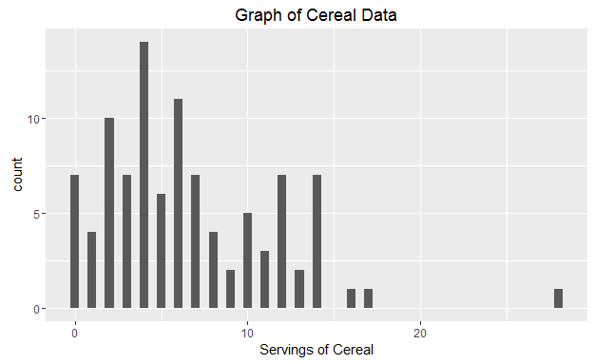

  - Use a Poisson GzLM (i.e. Poisson regression) to estimate the association between condition and number of breakfast servings, adjusting for sex and weight.

Poisson Model 1 Equation
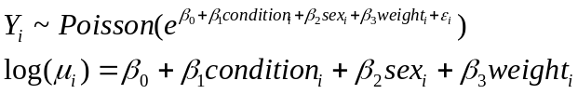

Table 1. Poisson GzLM Model 1.

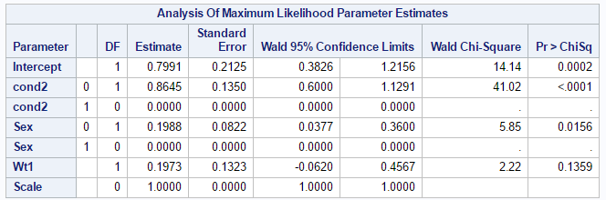

Results: There is a statistically significant association between experimental condition and the number of breakfast servings of cereal (p-value < 0.0001, Table 1). Since the for condition is greater than 0, this indicates that the experimental group (receiving some experimental intervention) compared to the control group has a larger number of breakfast servings of cereal by 2.235 (e^(0.8645)) times after adjusting for sex and weight from the Kid1 population.

  - Repeat (a) allowing for overdispersion by using quasilikelihood with the Poisson GzLM. Use the Deviance method for estimating the scale parameter. Show algebraically the relation between the QL SEs for the betas and those from the Poisson model in (a).

In addition to the Model above
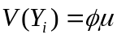

Using the quasipoisson distribution, the dispersion parameter is estimated to be 1.7651. The new standard error is larger (e.g. 0. 2383vs. 0.1350) where QL SE = Phi * ND SE.

QL SE = 0.2383; Quasi likelihood SE
ND SE = 0.1350; No dispersion SE
Phi = 1.7651; dispersion parameter.

Table 2. Poisson GzLM model 2 with overdispersion added
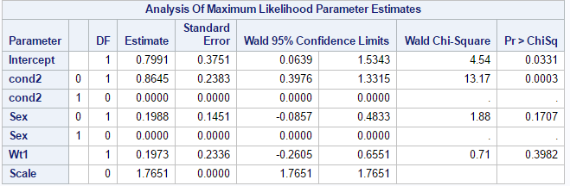

Result: The significance of the association between the experimental condition and number of breakfast serving of cereal still stand but slightly reduced (p-value = 0.0003, Table 2). The same magnitude of the effect holds from the previous question indicating that the experimental group (receiving some experimental intervention) compared to the control group has a larger number of breakfast servings of cereal by 2.235 (e^(0.8645)) times after adjusting for sex and weight from the Kid1 population.

  - Repeat (a) allowing for overdispersion by adding a random normal error to the linear predictor in the Poisson GzLM. This is a likelihood based method that is easiest in NLMIXED. I am not aware of an algebraic relation between these ML SE’s and those from the models in (a) or (b).

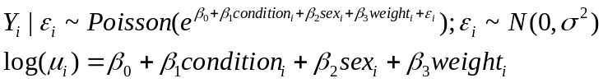
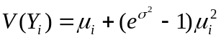

Table 3. Poisson GzLM with random normal error to linear predictor.
Parameter Estimates
Parameter | Estimate | Standard  Error | DF | t Value | Pr > |t| | 95% Confidence Limits |  | Gradient
Intercept | 0.1162 | 0.1458 | 98 | 0.80 | 0.4276 | -0.1733 | 0.4056 | 8.098E-6
Cond2_0 | 0.9855 | 0.1107 | 98 | 8.90 | <.0001 | 0.7659 | 1.2052 | 7.528E-6
Cond2_1 | 0.1307 | 0.1340 | 98 | 0.98 | 0.3318 | -0.1352 | 0.3965 | 5.703E-7
Sex_0 | 0.6346 | 0.09353 | 98 | 6.79 | <.0001 | 0.4490 | 0.8203 | -4.1E-6
Sex_1 | 0.4815 | 0.1107 | 98 | 4.35 | <.0001 | 0.2619 | 0.7012 | 0.000012
Wt | 0.1634 | 0.2372 | 98 | 0.69 | 0.4925 | -0.3073 | 0.6341 | 0.000011
sig | 0.5468 | 0.06852 | 98 | 7.98 | <.0001 | 0.4108 | 0.6827 | -7.26E-6

Additional Estimates
Label | Estimate | Standard | DF | t Value | Pr > |t| | Alpha | Lower | Upper
Label | Estimate | Error
Cond2 (exp) | 0.8549 | 0.1978 | 98 | 4.32 | <.0001 | 0.05 | 0.4624 | 1.2474
Sex (male) | 0.1531 | 0.144 | 98 | 1.06 | 0.2903 | 0.05 | -0.1327 | 0.4388

Result: The significance of the association between the experimental condition and number of breakfast serving of cereal still stand (p-value < 0.05, Table 3). The same magnitude of the effect holds from the previous question indicating that the experimental group (receiving some experimental intervention) compared to the control group has a larger number of breakfast servings of cereal by 2.350904 (e^(0.9855-0.1307)) times after adjusting for sex and weight from the Kid1 population.

  - Repeat (a) allowing for overdispersion by using a Negative Binomial GzLM. This is a likelihood based method. Do this in NLMIXED (it can also be done in GENMOD but that uses a different parameterization). I am not aware of an algebraic relation between these ML SE’s and those from the models in (a), (b), or (c).

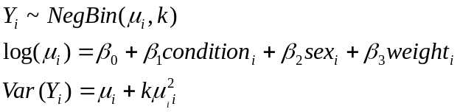
Negative binomial parameterized in terms of mean 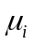and dispersion parameter k.

Table 4. Negative Binomial Distribution of Model
Analysis Of Maximum Likelihood Parameter Estimates
Parameter |  | DF | Estimate | Standard  Error | Wald 95% Confidence Limits |  | Wald Chi-Square | Pr > ChiSq
Intercept |  | 1 | 0.9344 | 0.3680 | 0.2131 | 1.6557 | 6.45 | 0.0111
cond2 (exp) | 0 | 1 | 0.8573 | 0.2149 | 0.4361 | 1.2786 | 15.91 | <.0001
cond2 | 1 | 0 | 0.0000 | 0.0000 | 0.0000 | 0.0000 | . | .
Sex (male) | 0 | 1 | 0.1711 | 0.1551 | -0.1330 | 0.4752 | 1.22 | 0.2702
Sex | 1 | 0 | 0.0000 | 0.0000 | 0.0000 | 0.0000 | . | .
Wt1 |  | 1 | 0.0994 | 0.2643 | -0.4187 | 0.6175 | 0.14 | 0.7068
Dispersion |  | 1 | 0.3160 | 0.0790 | 0.1937 | 0.5157

Result: The association between the experimental condition and the number of breakfast serving of cereal is still statistically significant (p-value < 0.05, Table 4). The magnitude of the effect of being in the control group on number of breakfast serving of cereal has changed (slightly) indicating that the experimental group (receiving some experimental intervention) compared to the control group has a larger number of breakfast servings of cereal by 2.356789 (e^(0.0.8573)) times after adjusting for sex and weight from the Kid1 population.

2. As before use data for kid 1 only, at baseline only (C1), as in question 1 above. You don’t need to fit any new models.

- Use the chart below to summarize the models you fit in question 2 comparing Conditions and adjusting for Sex and Weight. In each entry except ‘Intercept’ and ‘Other param’ give the estimate of the rate ratio and a 95% CI (these are easy to calculate from the beta and SE). For ‘Intercept’ give the beta and its SE. For ‘Other param’, give the Scale parameter for QL, the SD for the normal error model, or the dispersion parameter for NB, but not the SE. QL=Quasilikelihood, NB=Negative Binomial.

 | Poisson regression | Poisson QL | Poisson + normal error | NB NLMIXED
Intercept | 0.7991,  0.2125 | 0.7991, 0.3751 | 0.1162, 0.1458 | 0.9344,  0.3368
Cond (Exp) | 2.373819  (1.822119  , 3.092872) | 2.373819  (1.488249,  3.786719) | 2.351139  (1.58788,  3.48128) | 2.356789  (1.602877,  3.465303)
Sex (Male) | 1.219938  (1.03842,  1.433329) | 1.219938  (0.91787,  1.621416) | 1.165442  (0.875728,  1.550845) | 1.186609  (0.898346,  1.567371)
Wt | 1.218109  (0.939883,  1.578855) | 1.218109  (0.770666,  1.925335) | 1.177508  (0.73543,  1.885325) | 1.104508  (0.687495,  1.774644)
Other param | NA | 1.7651 | 0.5468 | 0.3160
AIC | 635.0355 | 635.0355 | 564.1 | 556.5421
Res. Dev | 295.98 | 295.98 |  | 113.4403
R df | 95 | 95 |  | 95
Dev/df | 3.1156 | 3.1156 |  | 1.1941

- Write a short paragraph summarizing the results of comparing conditions, e.g. which condition gives higher consumption and by how much.

Based on the four different models we fit, the experiment group has a larger number of breakfast servings of cereal by 2.4 times compared to the control group after adjusting for gender and weight (p-value < 0.05). Thus in general, the experimental group gives higher consumption.

c. Write a short paragraph comparing the model fits, e.g. differences between models.

Based on the AIC, the negative binomial has the lowest AIC value indicating better fit compared to regular Poisson, Poisson with dispersion, and Poisson with normal error. Also something to consider is the Deviance/df value (of 1.19 vs. 3.1156) which indicates a good fit of the negative binomial model with regards to dispersion parameter (want ~1 for value/df).

Appendix Code;
*import from sas university edition;
PROC IMPORT DBMS=csv OUT=Cereal2
DATAFILE="/folders/myshortcuts/FS2016/Longitudinal/Gary/Cereal2.csv";
GETNAMES=YES;
RUN;
*Data Managment;
*Appendix Create indicator variables for NLmixed;
DATA creal1 ;
SET creal1 ;
IF cond2= 0 THEN cond2_0 = 1;
ELSE cond2_0 = 0;
IF cond2 = 1 THEN cond2_1 = 1;
ELSE cond2_1 = 0;
IF sex = 0 THEN sex_0 = 1;
ELSE sex_0 = 0;
IF sex = 1 THEN sex_1 = 1;
ELSE sex_1 = 0;
RUN;
/*create new variable cond2 and keep the interested variables*/
data creal1(keep=cond cond2 C1 FamIDNO FamMem Sex Age1 Ht1 Wt1);
set Cereal2; cond2=1-cond; if FamMem=3;
run;
proc print data= creal1(obs=20); run;
/*1a: Poisson*/
PROC GENMOD data=creal1;
CLASS cond2(ref=last) sex;
MODEL C1 = cond2 sex Wt1 / dist = poisson link=log;
RUN;
/*1b: Overdispersion QL*/
PROC GENMOD data=creal1;
CLASS cond2(ref=last) sex;
MODEL C1 = cond2 sex Wt1 / dist = poisson link=log dscale;
RUN;
/*1C: overdispersion by adding a random normal error to the linear
predictor in the Poisson GzLM*/
proc nlmixed data=creal1;
title 'REGULAR NLMIXED';
eta = b0 + b1*cond2_0 + b2*cond2_1 + b3*sex_0 + b4*sex_1 + b5*wt1 + eps; mu = exp(eta);
model c1 ~ poisson(mu);
random eps ~ normal(0, sig*sig) subject=famidno;
estimate 'b1-b2' b1-b2;
estimate 'b3-b4' b3-b4;
run;
proc nlmixed data=creal1;
title 'NLMINXED+error&#39';
Model C1 ~ Poisson( exp( b0 + b1*cond2_0 + b2*cond2_1 + b3*sex_0 + b4*sex_1 + b5*wt1 + eps));
random eps ~ normal( 0, sig*sig ) subject=famidno; run;
*HW1D: Negative Binomial;
proc nlmixed data=creal1;
mu = exp( b0 +b1*cond2_0 + b2*cond2_1 + b3*sex_0 + b4*sex_1 + b5*wt1 );
LL = C1*log(k*mu) - (C1+1/k)*log(1+k*mu) + log(gamma(C1+1/k) /
(gamma(1/k)*gamma(C1+1)));
model C1 ~ general( LL );
estimate 'b1-b2' b1-b2;
estimate 'b3-b4' b3-b4;
run;
*HW1D: Negative Binomial;
proc genmod data=creal1;
class cond2 sex;
model C1 = cond2 sex Wt1 / dist = negbin link = log dscale;
run;

